Deep convolutional neural network for the automated diagnosis of congestive heart failure using ECG signals

利用心电信号自动诊断充血性心力衰竭的深度卷积神经网络

U Rajendra Acharya1,2,3,7 ,Hamido Fujita4,7 Shu Lih Oh1Yuki Hagiwara1，Jen Hong Tan1Muhammad Adam1，Ru San Tan5,6

1,Department of Electronics and Computer Engineering, Ngee Ann Polytechnic, Singapore, Singapore(新加坡义安理工学院电子与计算机工程系，新加坡)

2,Department of Biomedical Engineering, School of Science and Technology, Singapore University of Social Sciences, Singapore, Singapore(新加坡社会科学大学科技学院生物医学工程系，新加坡，新加坡)

3,Department of Biomedical Engineering, Faculty of Engineering, University of Malaya, Kuala Lumpur, Malaysia(马来西亚吉隆坡马来亚大学工程学院生物医学工程系)

4,Faculty of Software and Information Science, Iwate Prefectural University (IPU), Iwate, Japan(日本岩手县立大学(IPU)软件与信息科学学院)

5,National Heart Centre Singapore, Singapore, Singapore(新加坡国家心脏中心)

6,Duke-National University of Singapore Medical School, Singapore, Singapore(新加坡国立大学医学院，新加坡，新加坡)

7,Present address: Faculty of Software and Information Science, Iwate Prefectural University (IPU), Iwate 020-0693 Japan(现任地址:日本岩手县立大学软件与信息科学学院，岩手020-0693)

**1 Introduction引言**

Congestive heart failure (CHF) is a pathophysiological syndrome where there is abnormal filling and/or emptying of the left heart chamber.(充血性心力衰竭(CHF)是一种病理生理综合征，其表现为左心腔[1]异常充盈和/或排空。)It is caused by structural and/or functional derangements due to - and can also be considered the final stage of - diverse heart diseases.(它是由多种心脏病引起的结构和/或功能紊乱引起的，也可以认为是多种心脏病的最后阶段。)The prevalence and incidence of CHF are increasing, with approximately 26 million adults diagnosed with CHF worldwide in 2014 [2].CHF的患病率和发病率正在上升，2014年全球约有2600万成年人诊断为CHF。It is a major contributor to global mortality and morbidity, as well as an important factor for loss of quality life years and increased healthcare expenditure.它是全球死亡率和发病率的一个主要因素，也是丧失质量生命年和增加保健支出的一个重要因素。This is because of the debilitating symptoms such as breathlessness and fatigue experienced by sufferers of CHF.这是因为慢性心力衰竭患者会出现呼吸困难和疲劳等衰弱症状。Consequently, these patients experience a decline in their quality of life as they are increasingly unable to carry out physical and social activities [3].因此，这些患者的生活质量下降，因为他们越来越不能进行身体和社会活动[3]。 It is also noted that CHF predominantly affects the elderly (age >64 years) [4].我们还注意到CHF主要影响老年人(大于64岁)。Therefore, there is a need for early detection of CHF in the ageing population, which is a problem many countries in the world are facing right now.因此，需要在老龄化人口中早期发现CHF，这是目前世界上许多国家都面临的问题。In addition, CHF contributes to increased care and economic burden on patients’ families with around 40% of them having to struggle with their daily routine [3].此外，CHF增加了患者家庭的护理和经济负担，约40%的患者不得不为日常[3]而挣扎。早期检测将使预防措施和治疗机构得以建立，从而可能改变疾病的进程，并阻止老年人CHF的进展。Figure 1 shows the comparison of a healthy and a CHF heart with impaired pump function.图1显示了一个健康心脏和一个泵功能受损的CHF心脏的比较。

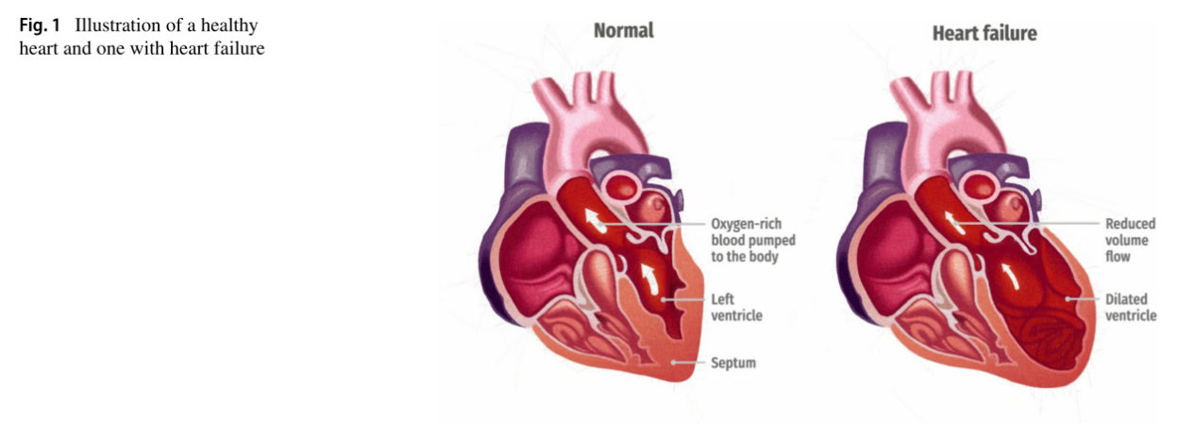

（图1健康心脏和心力衰竭心脏的图示）

（正常：把富氧的血液泵入体内 左心室 隔膜）

（心脏病：体积流量减少 扩大的心室）

In the healthy heart,there is good stroke volume (blood flow volume ejected per heart beat) and oxygen-rich blood is pumped to the body from the left ventricle.在健康的心脏中，有良好的每搏流量（每搏排出的血流量），富氧的血液从左心室泵入身体。However, in a common type of CHF with impaired pump function, stroke volume drops and the heart is unable to efficiently pump oxygen-rich blood to the rest of the body.然而，在泵送功能受损的一种常见类型的CHF中，每搏量下降，心脏无法有效地将富氧血液泵送至身体的其他部位。The heart is remodeled from the underlying disease process, becoming enlarged with stiff muscle walls as it is being stretched to hold more oxygen-rich blood to pump to the body.心脏在潜在的疾病过程中被重塑，当它被拉伸以容纳更多的富氧血液泵到身体时，它会因僵硬的肌壁而变大。The weakened pumping capacity results in easy fatiguability.泵送能力减弱导致易疲劳。It also causes blood and fluid to back up into the lungs and the body, resulting in breathlessness and generalized swelling, respectively [5].它还导致血液和液体回流到肺部和身体，导致呼吸困难和全身肿胀。

The diagnosis of CHF is a clinical one, requiring a conglomerate of symptoms and signs, as well as corroborative evidence from investigative tests.CHF的诊断是临床的，需要大量的症状和体征，以及来自调查性试验的确证。The electrocardiogram (ECG) is a noninvasive test commonly used by the healthcare professionals to record the heart activities of patients.心电图(ECG)是医疗保健专业人员常用来记录患者心脏活动的一种无创检测方法。Although the ECG signals are altered in CHF, the changes are non-specific and by themselves, are insensitive and not specific for diagnosis of CHF when using standard manual analytic methods.虽然CHF的心电信号发生改变，但这种改变本身是非特异性的，使用标准的手工分析方法诊断CHF时是不敏感的，也不是特异性的。Typically, the recorded ECG signals are visually examined by cardiologists for the detection of any abnormalities present in the signals.通常情况下，心脏科医生会对记录的心电图信号进行视觉检查，以发现信号中存在的任何异常。However, visual assessment of different ECG readings recorded from various patients is time-consuming.然而，对不同患者的不同心电图读数进行视觉评估是费时的。Further, manual interpretation of the ECG signals may be subject to inter-observer variability.此外，ECG信号的手动解释可能受制于观察者之间的可变性。

**2 Related work**相关工作

Many different traditional machine learning techniques have been employed to surmount the inadequacies of manual analysis of ECG signals in CHF (refer to Table 10).许多不同的传统机器学习技术被用来克服人工分析心电信号在CHF中的不足(见表10)。Traditional machine learning technique refers to an algorithm which has pre-processing, feature extraction and selection, and classification processes.传统的机器学习技术是指一种具有预处理、特征提取和选择以及分类过程的算法。The selection of distinctive features between normal and CHF signals is difficult and involves a lot of time and effort.在正常和CHF信号之间选择明显的特征是困难的，需要花费大量的时间和精力。Also, the robustness of the features extracted from the signals is dependent upon the quality of data.此外，从信号中提取的特征的鲁棒性取决于数据的质量。Pre-processing of the signals such as noise removal and R-peak detection are required in order to extract the most significant features for classification.为了提取最显著的特征进行分类，需要对信号进行去噪和r峰检测等预处理。To avoid the pitfalls of traditional machine learning, we propose deep learning in this work in order to optimize the performance of an automated CHF diagnosis system.为了避免传统机器学习的缺陷，我们在本工作中提出了深度学习，以优化自动CHF诊断系统的性能。Deep learning is a form of machine learning approach where the network learns and picks up distinct characteristics automatically based on the input ECG signals [6].深度学习是一种机器学习方法，网络根据输入的心电信号[6]自动学习并提取明显的特征。

Convolutional neural network (CNN) is one of the forms of deep learning which has been widely employed in speech and image recognition [7] and is receiving plenty of attention in the medical field [7].卷积神经网络(Convolutional neural network, CNN)是深度学习的一种形式，广泛应用于语音和图像识别领域[7]，并在医学领域[7]得到了广泛的关注。Recently, researchers are using CNN models to develop computer-aided diagnosis system to diagnose diverse medical conditions [8–17].最近，研究者正在利用CNN模型开发计算机辅助诊断系统，以诊断多种医疗状况[8-17]。The authors have employed CNN models in the detection of various heart diseases such as identifying arrhythmias with 2-seconds and 5-seconds ECG segments [13], diagnosing myocardial infarction ECG beats with and without noise removal [14], distinguishing coronary artery disease ECG signals from normal ECG signals with 2-seconds and 5-seconds signals [15], classifying 5 different types of heartbeats with ECG beats [16], and lastly, the detection of shockable and non-shockable 2-seconds ECG ventricular arrhythmias [17].作者使用CNN模型检测各种心脏疾病，如2秒和5秒心电图段识别心律失常[13]，在去除噪声和不去除噪声的情况下诊断心肌梗死心电图搏动[14]，用2秒和5秒信号区分冠状动脉疾病心电图信号与正常心电图信号[15]，用心电图心跳分类5种不同类型的心跳[16]，最后检测可电击和不可电击的2秒心电图室性心律失常。These published works have demonstrated relatively good performance with minimum pre-processing and no feature extraction or selection. 这些已发表的作品表现出了相对较好的性能，最少的预处理以及没有特征提取或选择。Lately, Tan et al. [18] designed a long-short term memory (LSTM) with CNN to diagnose coronary artery disease.最近，Tan等[18]与CNN一起设计了一种长短时记忆(LSTM)来诊断冠状动脉疾病。Their network achieved a high diagnostic accuracy of 99.85%.他们的网络达到了99.85%的高诊断准确率。But, as compared to the LSTM network, CNN has faster computational time and is less complex.但是，与LSTM网络相比，CNN具有更快的计算时间和更少的复杂性。Hence, this paper uses a deep CNN model (11-layers) to study the automatic classification of ECG signals into normal and CHF classes.

因此，本文采用深度CNN模型(11层)研究心电信号自动分类为正常和CHF类。

**3 Materials used**材料

The ECG signals used in this work were obtained from public databases (PhysioBank) namely the Beth Israel Deaconess Medical Centre (BIDMC) Congestive Heart Failure Database, Fantasia Database, and MIT-BIH Normal Sinus Rhythm Database (NSRDB) [19].这项工作中使用的心电信号来自公共数据库(PhysioBank)，即贝斯以色列女执事医疗中心(BIDMC)充血性心力衰竭数据库、Fantasia数据库和MIT-BIH正常窦性节律数据库(NSRDB)[19]。Table 1 summarizes the details of the ECG data collected from each database.表1总结了从每个数据库收集到的心电数据的细节。

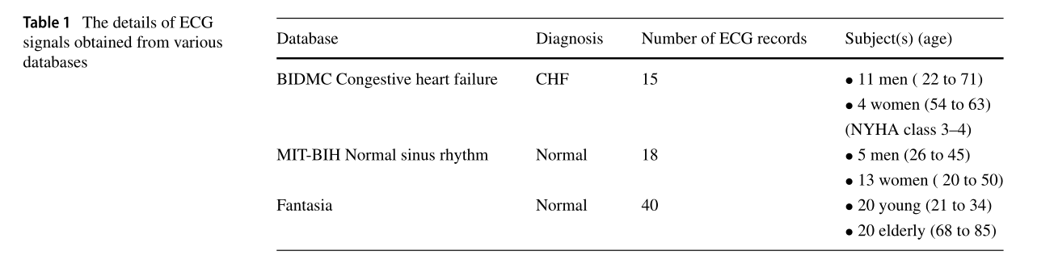

（表1各数据库心电信号的详细信息）

（数据库 贝斯以色列女执事医疗中心充血性心力衰竭数据库 Fantasia数据库 MIT-BIH正常窦性节律数据库）

The severity of CHF symptoms is graded based on the New Y ork Heart Association (NYHA) scale [20]:CHF症状的严重程度根据纽约心脏协会(NYHA)[20]分级:

Class 1: mild with no limitation of physical activity;(第1类:轻度，无体力活动限制;)

Class 2: mild with slight limitation of physical activity;(2级:轻度，体力活动受限;)

Class 3: moderate with marked limitation of physical activity; and(类别3:中度，体力活动受限;和)

Class 4: severe with total limitation of physical activity.(第4类:严重，体力活动完全受限。)

The CHF ECG data used in this work are in Class 3 and Class 4 categories.(本研究中使用的心衰心电图数据分为3类和4类。)

A total of four datasets (Set A, Set B, Set C, and Set D) are used in this work.(本工作共使用4个数据集(Set A, Set B, Set C, Set D)。)Both Sets A and B consist of full ECG data (unbalanced), while Sets C and D have balanced number of ECG data (see Table 2). 30,000 normal ECG data are randomly selected from the full set for Sets C and D.A组和B组均为全心电数据(不平衡)，C组和D组心电数据数量平衡(见表2)。从全组中随机选取30000份正常心电数据用于C组和D组。

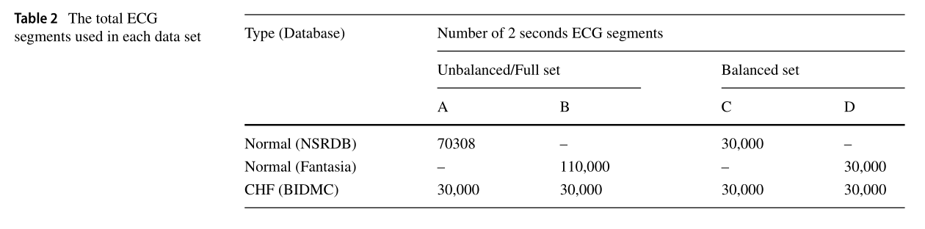

（表2各数据集所使用的总心电段数）

Figure 2 shows typical normal and CHF ECG segments obtained from the public databases.图2为从公共数据库中获得的典型正常心电和CHF心电片段。

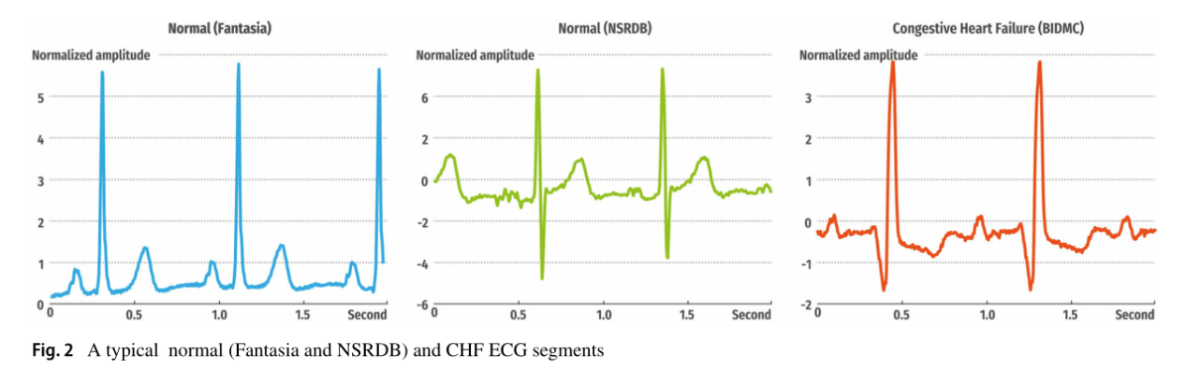

（图2典型正常(Fantasia和NSRDB)和CHF心电图片段 归一化振幅）

**4 Methodology方法**

**4.1 Pre-processing预处理**

The Fantasia and BIDMC ECG databases are sampled at 250 Hz frequency whereas the MIT-BIH Normal Sinus database (NSRDB) is sampled at 128 Hz frequency. Fantasia和BIDMC心电数据库以250 Hz频率采样，而MIT-BIH正常窦性心律数据库(NSRDB)以128 Hz频率采样。Therefore, the signals obtained from NSRDB are up sampled to 250 Hz.因此，从NSRDB中获得的信号被上采样到250 Hz。This ensures that the frequency of ECG signals is standardized. 这确保了ECG信号的频率标准化。 Then, the ECG records were segmented into 2 seconds ECGs (without performing R-peak detection).然后将心电图记录分割成2秒的心电图(不做r峰检测)。Each ECG signal (2 seconds) is 500 samples in length.每个2秒的心电信号是500个样本的长度。

Also, each ECG signal is regularized with Z score normalization, standard deviation of 1, and zero mean before inputting into the network.每一个心电信号在输入到网络之前都经过Z分数归一化、标准差为1、均值为0的标准化处理。

**4.2 CNN architecture** CNN架构

The details of the proposed CNN model are tabulated in Table 3 and the graphical representation of the architecture can be seen in Fig. 3.所提出的CNN模型的详细信息如表3所示，其架构的图形表示如图3所示。The number of layers and the tuning parameters are varied by a brute force method until the optimum diagnostic performance is achieved.层数和调优参数通过蛮力方法变化，直到达到最佳的诊断性能。Hence, the proposed model consists of 4 convolutions, 4 max-pooling, and 3 fully-connected layers.因此，该模型由4个卷积、4个最大池化和3个全连接层组成。The stride (the amount by which the filter shifts) is set at 1 and 2 for convolution and max-pooling respectively in this work.在本工作中，卷积和max-pooling的stride(滤波器移动的量)分别设置为1和2。These layers make up the fundamental structure of CNN whereby convolution picks up distinctive features from the input ECG signal.这些层构成了CNN的基本结构，通过卷积从输入的心电信号中提取独特的特征。The max-pooling operation reduces the dimensions of feature maps and at the same time retain important and significant features of the input ECG signal.最大池化操作降低了特征图的维数，同时保留了输入心电信号的重要和显著特征。The max-pooling is performed after every convolution operation in this work.在本工作中，每次卷积运算后都执行最大池化。Lastly, the fully-connected layer is intended to connect the neurons in the previous layers into a two-class (normal or CHF) probability distribution.最后，全连接层旨在将前一层中的神经元连接成两类(正态或CHF)概率分布。

Layer 0 (input layer) is convolved with a size 5 kernel (filter) to produce the first layer.第0层(输入层)与大小为5的核(滤波器)进行卷积以产生第一层。Then, a max-pooling operation (kernel 2) is administered on layer 1 (496 × 5) to form layer 2 (248 × 5).然后，在第1层(496 × 5)上执行一个最大池操作(内核2)，形成第2层(248 × 5)。After which, in layer 2, a convolution is performed with a filter (size 5) to construct layer 3.然后，在第2层，用一个滤波器(大小为5)进行卷积来构造第3层。Then, a max-pooling is once again applied to decrease the number of output neurons. Again, a convolution is performed in layer 4 (122 × 5) with a kernel size 3 to form layer 5.然后，再次使用最大池化来减少输出神经元的数量。同样，在第4层(122 × 5)执行卷积，核大小为3，形成第5层。Then, a max-pooling is performed to decrease the number of neurons from 120 × 10 to 60 × 10 (layer 6).然后通过最大池化将神经元数量从120 × 10减少到60 × 10(第6层)。Another round of convolution with kernel size 3 is applied followed by one last max-pooling operation to form layer 8 with 29 × 10 neurons.应用内核大小为3的另一轮卷积，然后执行最后一个max pooling操作，以形成29× 10个神经元的第8层。Layer 8 is fully-connected to 40 output neurons in layer 9 and fully-connected to 20 neurons in layer 10.第8层与第9层中的40个输出神经元完全连接，并与第10层中的20个神经元完全连接。Lastly, layer 10 is fully-connected to the final layer (layer 11) with 2 outputs which represent the two classification classes (normal and CHF).最后，第10层与最后一层(第11层)完全连接，其中有两个输出，代表两个分类类(normal和CHF)。

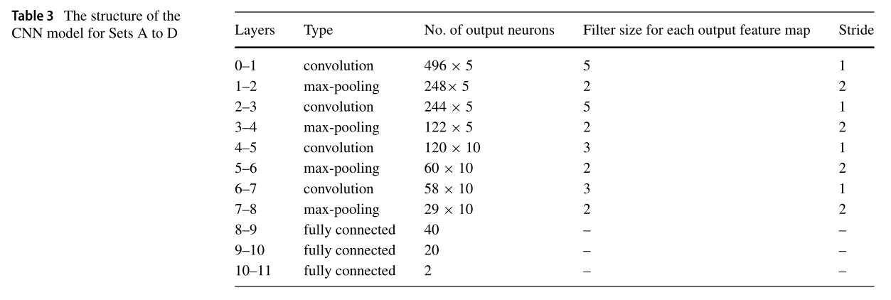

（表3集合A到D的CNN模型结构）

**4.3 Training and testing of CNN model（**CNN模型的训练与测试）

Xavier initialization is used to initialize the model weights [21].Xavier初始化用于初始化模型权重[21]。A backpropagation [22] with a batch size of 10 is used to update the CNN model in this study.本研究使用的batch size为10，使用反向传播来更新CNN模型。The network loss is evaluated using the cross-entropy function.利用交叉熵函数评估网络损耗。

The parameters used to train the proposed CNN structure in order to yield the maximum diagnostic performance are lambda (L1 regularization) = 0.2, learning rate = 3x10−4 and momentum = 0.3.为了获得最大的诊断性能，用于训练所提出CNN结构的lambda (L1正则化)= 0.2，学习率= 0.0003和动量= 0.3。These parameters help to impede overfitting of the data (regularization), assist in data convergent (learning rate), and adjust the speed of the learning (momentum) [23].这些参数有助于防止数据过拟合(正则化)，有助于数据收敛(学习率)，调节学习速度(动量)。

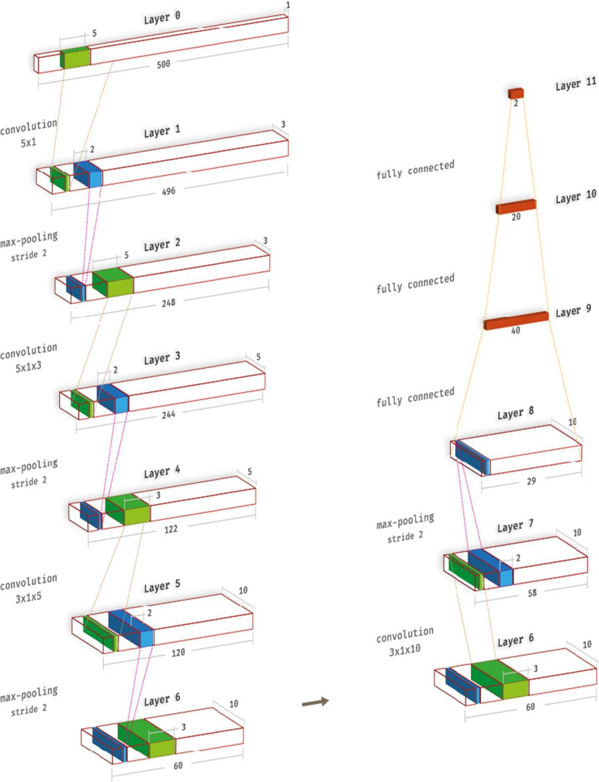

**Fig 3 提出的CNN模型的架构**

Furthermore, leaky rectifier linear unit (LeakyRelu) [24] shown in (1) is employed as activation function for layers 1, 3, 5, 7, 9, and 10 whereas layer 11 implemented the SoftMax function as seen in (2).此外，(1)中所示的带泄露修正线性单元(LeakyRelu)作为第1、3、5、7、9、10层的激活函数，而第11层实现了如(2)所示的SoftMax函数。

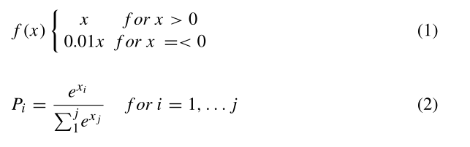

Where f(x) represents the function, Pi is the probability distribution over the total possible classes, and j denotes the total number of classes.其中f(x)表示函数，Piis表示所有可能类的概率分布，j表示类的总数。Stratified ten-fold cross-validation strategy [25] i s performed in this work.本研究采用十倍交叉验证策略。The ECG segments of four sets are divided into ten parts.四组心电图分段分为十部分。Nine parts are used to train the model whilst the remaining part is used to test the model.

9个部分用于训练模型，其余部分用于测试模型。Each divided part contains approximately the same target class percentage as the entire dataset.每个分割的部分包含与整个数据集大致相同的目标类百分比。Ten iterations are conducted in this work.在这项工作中进行了10次迭代。The average of the ten iterations for the four sets are tabulated in Table 9.这四组的10次迭代的平均值列在表9中。

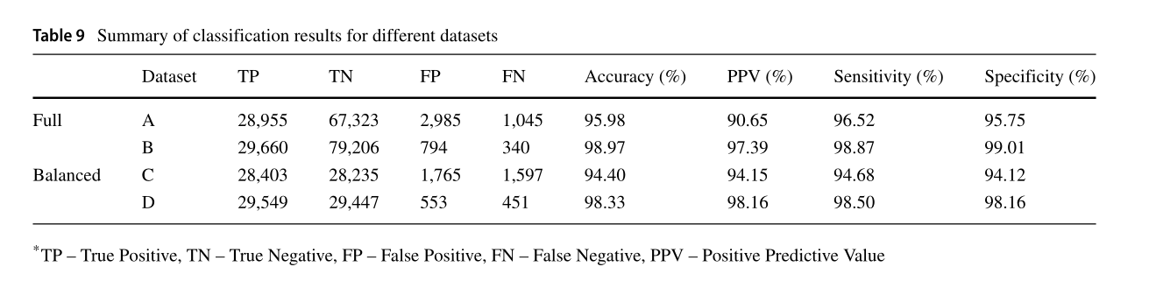（表9不同数据集的分类结果摘要 TP -真阳性 TN -真阴性 FP -假阳性 FN -假阴性 PPV -阳性预测值）

（Acc = (TP+TN)/(TP+FP+TN+FN) PPV=TP/(TP+FP) Sen=TP/(TP+FN) Spe = TN/(TN+FP) ）

**5 Results** 结果

Two Intel Xeon 2.40 GHz (E5620) processor and a 24 GB RAM are used to train the proposed network without the implementation of a graphics processing unit (GPU).两个Intel Xeon 2.40 GHz（E5620）处理器和一个24 GB RAM用于训练所提出的网络，而无需实现图形处理单元（GPU）。Table 4 shows the average time needed to train an epoch for each dataset. 60 epochs are run in this study to develop the model.表4显示了为每个数据集训练epoch所需的平均时间。为了建立模型，本研究进行了60个时期的研究。

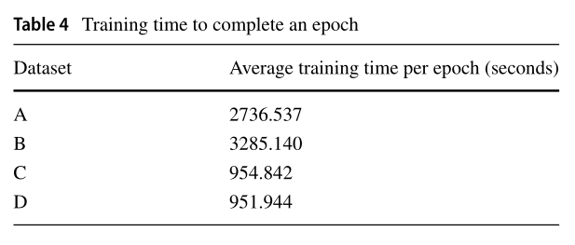

（表4平均每轮训练时间）

The confusion matrix for sets A to D are shown in Tables 5, 6, 7 and 8 respectively. Table 9 shows the overall average performance to classify normal and CHF classes with our proposed CNN model. The proposed CNN model achieved the highest accuracy of 98.97%, sensitivity of 98.87%, and specificity of 99.01% for Set B.（A组到D组的混淆矩阵分别见表5、表6、表7、表8。表9显示了我们提出的CNN模型对正常类和CHF类分类的总体平均性能。所提出的CNN模型对Set B的准确率最高，为98.97%，灵敏度为98.87%，特异性为99.01%。）

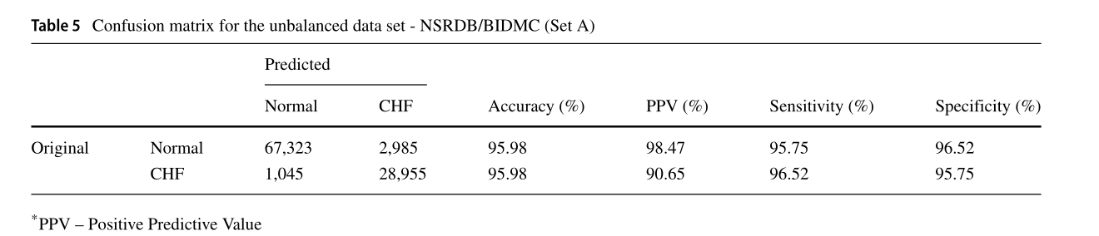

（表5非平衡数据集的混淆矩阵- NSRDB/BIDMC(集A) PPV -阳性预测值）

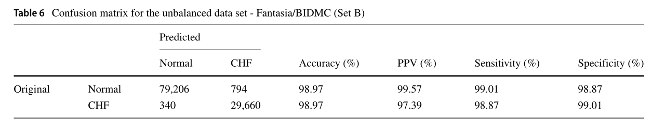

（表6不平衡数据集混淆矩阵- Fantasia/BIDMC(集B)）

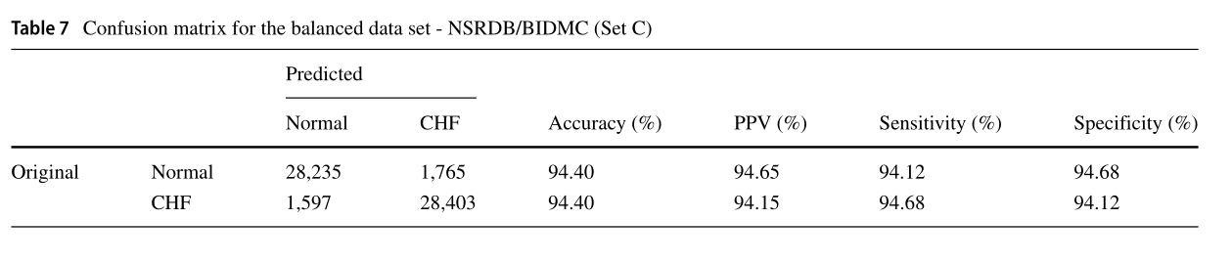

（表7平衡数据集混淆矩阵- NSRDB/BIDMC(集合C)）

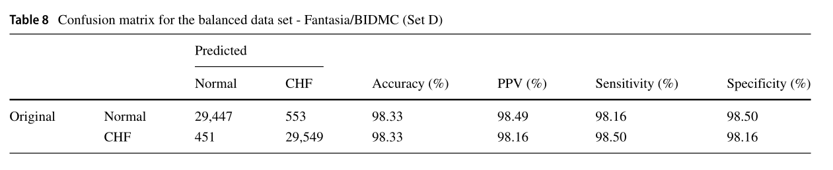

（表8平衡数据集- Fantasia/BIDMC混淆矩阵(集D)）

In Set A, 95.75% of the normal ECG segments are correctly classified in the normal class and 96.52% of CHF signals are correctly classified in the CHF class.在集合A中，95.75%的正常心电段正确分类为正常类，96.52%的CHF信号正确分类为CHF类。Only 4.25% and 3.48% of the ECG signals are incorrectly categorized as CHF and normal class respectively.只有4.25%和3.48%的心电信号被错误分类为CHF和正常。Also, in Set B, a very small percentage of approximately 0.99% normal ECG signals are incorrectly grouped as CHF class, and 1.13% of CHF ECG signals are misclassified into the normal class.另外，在B组中，约0.99%的正常心电信号被错误地划分为CHF类的比例非常小，有1.13%的CHF心电信号被错误地划分为正常类。

Likewise, 5.88% of normal ECG signals are wrongly classified to CHF class in Set C.同样，在C组中，5.88%的正常心电信号被误分为CHF类。Also, the misclassification rate of CHF ECG signals is about 5.32%. Set D attained better classification results than Set C with 1.84% of CHF ECG signals and 1.50% of normal ECG signals wrongly classified into normal and CHF classes, respectively.CHF心电图信号的误分率约为5.32%。D组的分类结果优于C组，分别有1.84%的CHF心电信号和1.50%的正常心电信号被误分为正常和CHF类。

**6 Discussion** 讨论

Based on Table 9, it can be noted that Set B and Set D achieved better performance as compared to Set A and Set C.由表9可知，B组和D组的性能优于A组和C组。In addition, it can also be observed that the full set (Set A and Set B) yielded better performance as compared to the balanced set (Set C and Set D).此外，还可以观察到，与平衡集（集C和集D）相比，全集（集A和集B）产生了更好的性能。This might be because more variations in the large number of ECG signals (see Table 2) in the full set ensure more diversity learning during training and hence helped to achieve better results than in the balanced set.这可能是因为在大量心电信号(见表2)集合中有更多的变化，确保在训练过程中有更多的多样性学习，因此有助于比在平衡集合中获得更好的结果。Also, the quality of the ECG signals may affect the overall diagnostic performance. Out of the four sets, Set B is reported to achieve the highest diagnostic accuracy of 98.97%.此外，心电信号的质量可能会影响整体诊断性能。在四组中，B组的诊断准确率最高，为98.97%。表10讨论了利用从PhysioBank获得的心电信号自动检测CHF的不同算法。The different techniques recorded in Table 10 yielded high diagnostic performance. Most of the works listed in Table 10 performed denoising and Rpeak detection in the pre-processing step.表10中记录的不同技术产生了高诊断性能。表10中列出的大部分工作都是在预处理步骤中进行去噪和Rpeak检测。But, our proposed CNN model does not require any processing of the ECG data. Further, the majority of the ECG signals are either segmented into an ECG beat or into different segments of ECG signals. However, in this work, the ECG signals used are shorter in duration.但是，我们提出的CNN模型不需要对心电数据进行任何处理。此外，大部分心电信号要么被分割成一个心电节拍，要么分割成不同的心电信号段。然而，在这项工作中，使用的心电信号持续时间较短。Although the proposed CNN model did not obtain 100.00% accuracy in the classification of normal and CHF ECG signals, this study is the first to implement a CNN model to classify ECG signals into normal and CHF classes.虽然所提出的CNN模型对正常心电信号和CHF心电信号的分类准确率没有达到100.00%，但本研究首次实现了将心电信号分类为正常心电信号和CHF心电信号的CNN模型。Unlike our proposed algorithm, the works in Table 10 adopted the conventional machine learning techniques. Hence, the novelty of this work is the development of an 11layer deep CNN model for the detection of CHF ECG signals.与我们提出的算法不同，表10中的工作采用了传统的机器学习技术。因此，本工作的新颖之处在于开发了一种用于CHF心电信号检测的11层深度CNN模型。

In this work, we have developed the deep learning model using short durations (2-seconds) of ECG signals to diagnose the CHF.在这项工作中，我们开发了利用短时间(2秒)心电信号诊断CHF的深度学习模型。Such deep learning model can also be implemented using HRV signals and echocardiographic images to identify CHF automatically.这种深度学习模型也可以利用HRV信号和超声心动图图像实现对CHF的自动识别。The authors have developed automated diagnostic system using heart rate variability (HRV) signals [26, 27] and echocardiographic images [28] to detect CHF.作者开发了利用心率变异性(HRV)信号[26,27]和超声心动图图像[28]来检测CHF的自动诊断系统。Hence, the authors intend to design a CNN model to automatically diagnose CHF using HRV signals or echocardiogram images.因此，作者打算使用HRV信号或超声心动图图像设计一个CNN模型来自动诊断CHF。

Also, this two-class (normal and CHF) diagnostic stratification can potentially be extended to four classes.此外，这种两级(正常和CHF)诊断分层可以潜在地扩展到四级。Acharya et al. [29] and Fujita et al. [30] developed an algorithm to diagnose normal, CHF, myocardial infarction (MI), and **coronary artery disease (CAD).** Acharya等人[29]和Fujita等人[30]开发了一种诊断正常、CHF、心肌梗死（MI）和冠状动脉疾病（CAD）的算法。Both works demonstrated high diagnostic performance (see Table 10). Moreover, our group has already performed automated diagnosis of CAD [15] a n d M I [14] with an 11-layer deep CNN model respectively.两项工作都显示了高诊断性能(见表10)。此外，我们小组已经分别使用11层深度CNN模型对CAD [15] 和MI[14]进行了自动诊断。We have also detected automatically non-ectopic, supraventricular ectopic, ventricular ectopic, fusion, and unknown ECG beats using CNN [16]. In future, the authors intend to develop a CNN model to detect the MI, CHF, CAD, and normal (four-class) ECG signals.我们还使用CNN自动检测非异位、室上异位、室异位、融合和未知的心电图。在未来，作者打算开发一个CNN模型来检测心肌梗死、CHF、CAD和正常(四类)心电信号。

The advantages of the proposed CNN model are:所提出的CNN模型的优点是:

• 11-layer deep CNN model is proposed •提出11层深度CNN模型

• Denoising is not required •不需要去噪

• R-peak detection is not required.•不需要r峰检测。

• Hand-crafted features are not required.•无需手工制作特征。

The limitations of the proposed CNN model are:所提出的CNN模型的局限性是:

• Requires big data to achieve the optimum performance.•需要大数据来实现最佳性能。

• Requires extensive computational power for training the model.•需要大量的计算能力来训练模型。

Nevertheless, running the proposed model with a graphics processing unit (GPU) will accelerate the time taken to train the model and reduces the processing power needed for training.然而，使用图形处理单元(GPU)运行提出的模型将加快训练模型所需的时间，并降低训练所需的处理能力。In addition, the performance will increase if there are more diverse ECG signals used to train the CNN mdoel.Hence, the advantages outweigh the drawbacks of this proposed deep CNN model.此外，如果有更多不同的心电信号用于训练CNN模型，性能将会提高。因此，本文提出的深度CNN模型优点大于缺点。

**7 Conclusion**总结

Unlike the conventional machine learning techniques, this study implemented an 11-layer deep CNN model to automatically diagnose CHF using ECG signals. The proposed model is fully-automatic and R-peak detection is not required.与传统的机器学习技术不同，本研究实现了一个11层深度CNN模型，利用心电信号自动诊断CHF。该模型是全自动的，不需要r峰检测。Also, four different sets of data obtained from PhysioBank were used to train and test the CNN model. Set B obtained the highest performance using our proposed model with an accuracy, specificity and sensitivity of 98.97%, 99.01% and 98.87% respectively.另外，使用PhysioBank获得的四组不同的数据来训练和测试CNN模型。采用我们提出的模型，B组的准确率最高，特异性和灵敏度分别为98.97%、99.01%和98.87%。Nevertheless, the diagnostic ability of the suggested model can be enhanced using huge ECG database belonging to different stages of CHF. It is anticipated such CNN models can also be developed to detect different cardiac diseases like dilated, ischemic, and hypertrophic cardiomyopathy.然而，基于不同心电阶段的庞大心电数据库可以提高模型的诊断能力。预计这种CNN模型也可以用于检测不同的心脏疾病，如扩张性、缺血性和肥厚性心肌病。

Once the CNN model is well-trained, it can be introduced in the healthcare industries as an adjunct tool to assist cardiologists in providing quick and reliable second opinions on the diagnosis.一旦CNN模型经过良好的训练，它就可以作为辅助工具被引入医疗保健行业，帮助心脏病学家提供快速可靠的诊断第二意见。

